**SMART WASTE MANAGEMENT SYSTEM FOR METROPOLITAN CITIES**

**ASSIGNMENT – 1**

SUBMITTED BY:

S.RAJALAKSHMI

ECE- IV

THAMIRABHARANI ENGNIEERING COLLEGE

**DISTANCE MEASUREMENT**

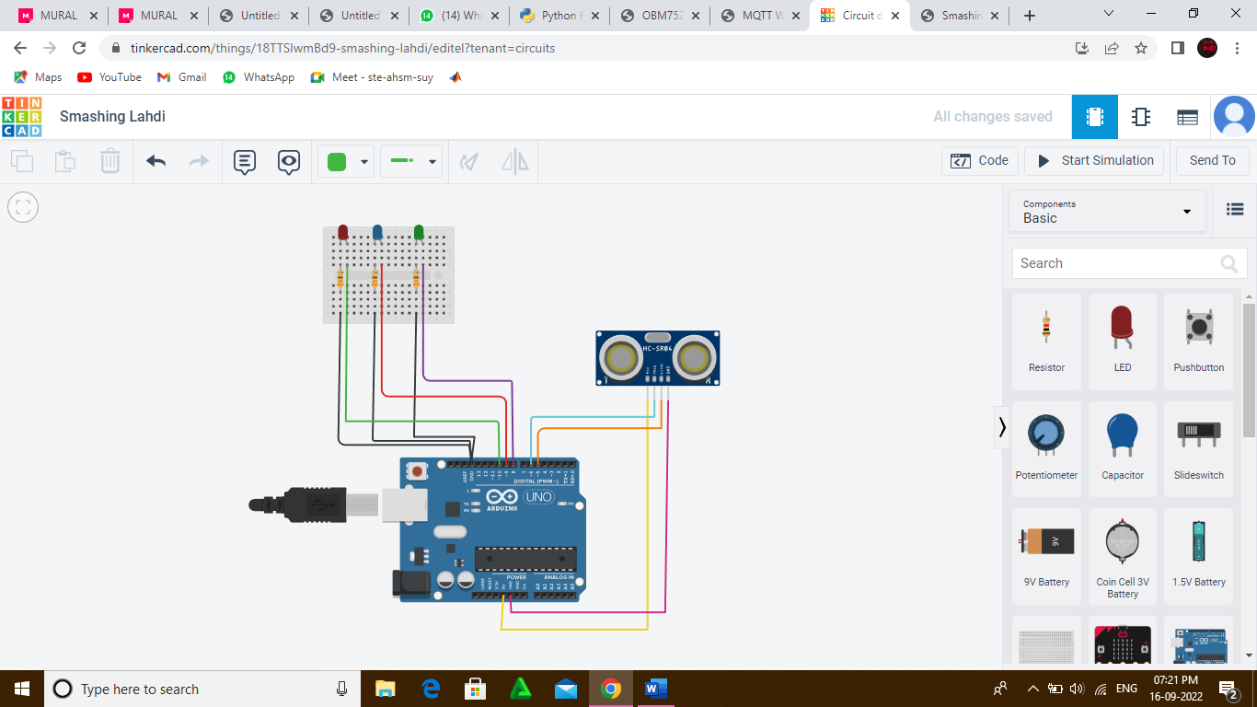

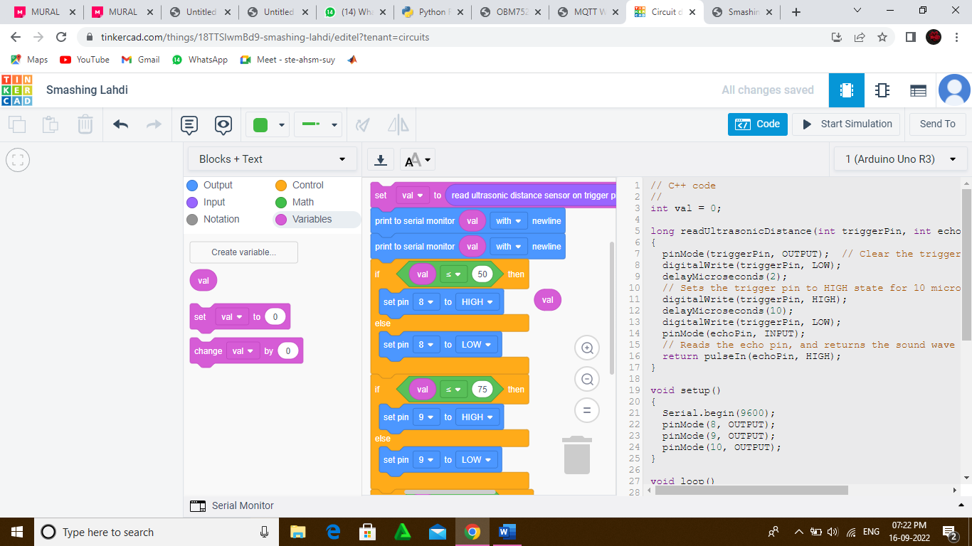

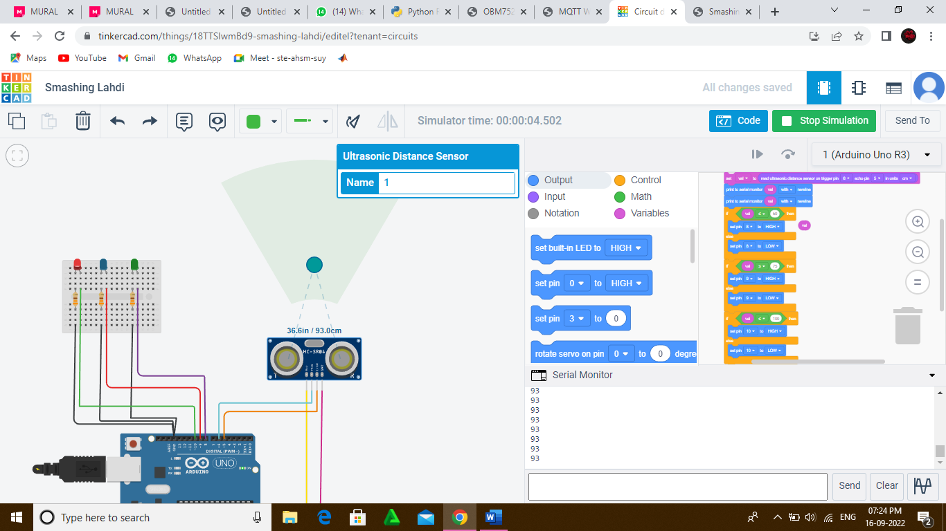

**Program**

// C++ code

//

int val = 0;

long readUltrasonicDistance(int triggerPin, int echoPin)

{

pinMode(triggerPin, OUTPUT); // Clear the trigger

digitalWrite(triggerPin, LOW);

delayMicroseconds(2);

// Sets the trigger pin to HIGH state for 10 microseconds

digitalWrite(triggerPin, HIGH);

delayMicroseconds(10);

digitalWrite(triggerPin, LOW);

pinMode(echoPin, INPUT);

// Reads the echo pin, and returns the sound wave travel time in microseconds

return pulseIn(echoPin, HIGH);

}

void setup()

{

Serial.begin(9600);

pinMode(8, OUTPUT);

pinMode(9, OUTPUT);

pinMode(10, OUTPUT);

}

void loop()

{

val = 0.01723 * readUltrasonicDistance(6, 5);

Serial.println(val);

Serial.print(val);

if (val <= 50) {

digitalWrite(8, HIGH);

} else {

digitalWrite(8, LOW);

}

if (val <= 75) {

digitalWrite(9, HIGH);

} else {

digitalWrite(9, LOW);

}

if (val <= 100) {

digitalWrite(10, HIGH);

} else {

digitalWrite(10, LOW);

}

delay(10); // Delay a little bit to improve simulation performance

}